
AGENDA ESCOLAR
2012 – 2013

ESCUELA:___________________________
C.C.T.________________________________
PROFESOR(A):_______________________
GRADO Y GRUPO:____________________

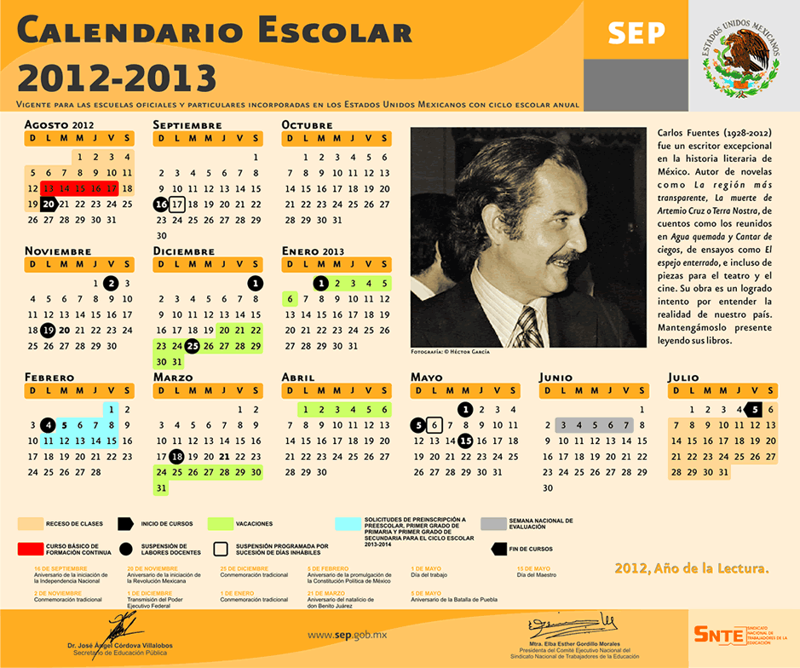
AGOSTO 
FELIZ REGRESO A CLASES!!

dom | lun | mar | mié | jue | vie | sáb
 |  |  | 1 | 2 | 3 | 4
5 | 6 | 7 | 8 | 9 | 10 | 11
12 | 13 | 14 | 15 | 16 | 17 | 18
19 | 20 | 21 | 22 | 23 | 24 | 25
26 | 27 | 28 | 29 | 30 | 31
OBSERVACIONES


SEPTIEMBRE
VIVA MÉXICO !!

dom | lun | mar | mié | jue | vie | sáb
 |  |  |  |  |  | 1
2 | 3 | 4 | 5 | 6 | 7 | 8
9 | 10 | 11 | 12 | 13 | 14 | 15
16 | 17 | 18 | 19 | 20 | 21 | 22
23/30 | 24 | 25 | 26 | 27 | 28 | 29
OBSERVACIONES



OCTUBRE
“ DIA DE LA RAZA” “DIA DE LA ONU”

dom | lun | mar | mié | jue | vie | sáb
 | 1 | 2 | 3 | 4 | 5 | 6
7 | 8 | 9 | 10 | 11 | 12 | 13
14 | 15 | 16 | 17 | 18 | 19 | 20
21 | 22 | 23 | 24 | 25 | 26 | 27
28 | 29 | 30 | 31
OBSERVACIONES
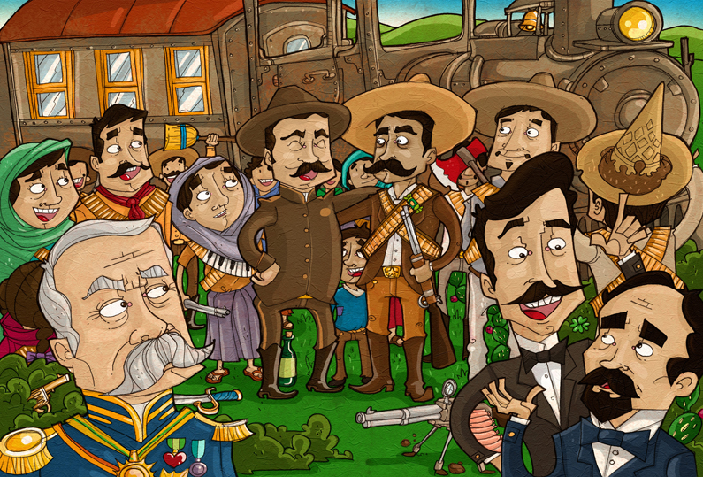
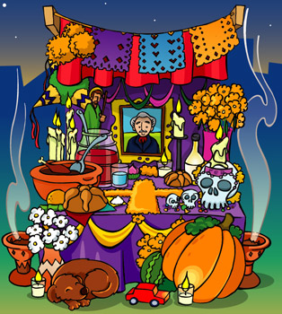
NOVIEMBRE
¨ DIA DE MUERTOS REVOLUCION MEXICANA¨

dom | lun | mar | mié | jue | vie | sáb
 |  |  |  | 1 | 2 | 3
4 | 5 | 6 | 7 | 8 | 9 | 10
11 | 12 | 13 | 14 | 15 | 16 | 17
18 | 19 | 20 | 21 | 22 | 23 | 24
25 | 26 | 27 | 28 | 29 | 30
OBSERVACIONES

DICIEMBRE
¨ FELIZ NAVIDAD¨

dom | lun | mar | mié | jue | vie | sáb
 |  |  |  |  |  | 1
2 | 3 | 4 | 5 | 6 | 7 | 8
9 | 10 | 11 | 12 | 13 | 14 | 15
16 | 17 | 18 | 19 | 20 | 21 | 22
23/30 | 24/31 | 25 | 26 | 27 | 28 | 29
OBSERVACIONES



ENERO
FELIZ AÑO NUEVO ¨ DIA DE REYES¨

dom | lun | mar | mié | jue | vie | sáb
 |  | 1 | 2 | 3 | 4 | 5
6 | 7 | 8 | 9 | 10 | 11 | 12
13 | 14 | 15 | 16 | 17 | 18 | 19
20 | 21 | 22 | 23 | 24 | 25 | 26
27 | 28 | 29 | 30 | 31
OBSERVACIONES


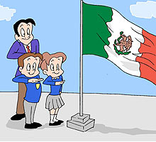
FEBRERO
DIA DE LA BANDERA “DIA DEL AMOR Y LA AMISTAD¨

dom | lun | mar | mié | jue | vie | sáb
 |  |  |  |  | 1 | 2
3 | 4 | 5 | 6 | 7 | 8 | 9
10 | 11 | 12 | 13 | 14 | 15 | 16
17 | 18 | 19 | 20 | 21 | 22 | 23
24 | 25 | 26 | 27 | 28
OBSERVACIONES


MARZO
¨ LLEGÓ LA PRIMAVERA¨

dom | lun | mar | mié | jue | vie | sáb
 |  |  |  |  | 1 | 2
3 | 4 | 5 | 6 | 7 | 8 | 9
10 | 11 | 12 | 13 | 14 | 15 | 16
17 | 18 | 19 | 20 | 21 | 22 | 23
24/31 | 25 | 26 | 27 | 28 | 29 | 30
OBSERVACIONES
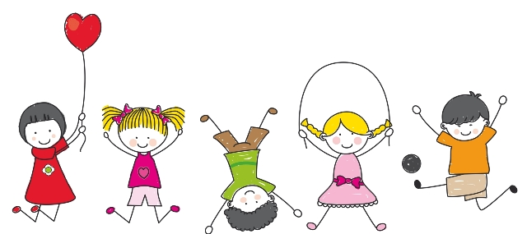
ABRIL
¨ FELIZ DIA DEL NIÑO¨

dom | lun | mar | mié | jue | vie | sáb
 | 1 | 2 | 3 | 4 | 5 | 6
7 | 8 | 9 | 10 | 11 | 12 | 13
14 | 15 | 16 | 17 | 18 | 19 | 20
21 | 22 | 23 | 24 | 25 | 26 | 27
28 | 29 | 30
OBSERVACIONES



MAYO
¨DIA DE LAS MADRES¨ ¨ DIA DEL MAESTRO¨

dom | lun | mar | mié | jue | vie | sáb
 |  |  | 1 | 2 | 3 | 4
5 | 6 | 7 | 8 | 9 | 10 | 11
12 | 13 | 14 | 15 | 16 | 17 | 18
19 | 20 | 21 | 22 | 23 | 24 | 25
26 | 27 | 28 | 29 | 30 | 31
OBSERVACIONES


JUNIO
¨ DIA DE LOS PADRES¨

dom | lun | mar | mié | jue | vie | sáb
 |  |  |  |  |  | 1
2 | 3 | 4 | 5 | 6 | 7 | 8
9 | 10 | 11 | 12 | 13 | 14 | 15
16 | 17 | 18 | 19 | 20 | 21 | 22
23/30 | 24 | 25 | 26 | 27 | 28 | 29
OBSERVACIONES

JULIO
¨ FELICES VACACIONES¨

dom | lun | mar | mié | jue | vie | sáb
 | 1 | 2 | 3 | 4 | 5 | 6
7 | 8 | 9 | 10 | 11 | 12 | 13
14 | 15 | 16 | 17 | 18 | 19 | 20
21 | 22 | 23 | 24 | 25 | 26 | 27
28 | 29 | 30 | 31
OBSERVACIONES

NOTAS DEL MES


____________________________________________________
____________________________________________________
____________________________________________________
____________________________________________________
____________________________________________________
___________________________________________________________________________________________________________________________________________________________________________________________________________________________________________________________________________________________________________________________________________________________________________________________________________________________________________________________________________________________________________________________________________________________________________________________________________________________________________________________________________________________________________________________________________________________________________________________________________________________________________________________________________________________________________________________________________________________________________________________________________________________________________________________________________________________________________________________________________________________________________________________________________________________________________________________________________________________________________________________________________________________________________________________________________________________________________________________________________________________________________________________________________________________________________________________________________________________________________________________________________________________________________________________________________



GRUPO




LISTA DE GRUPO

N. L. | N O M B R E D E L A L U M N O
1
2
3
4
5
6
7
8
9
10
11
12
13
14
15
16
17
18
19
20
21
22
23
24
25
26
27
28
29
30
31
32
33
34
35


D I R E C T O R I O D E G R U P O

N. L. | - CASA | - TRAB. MAMA | - TRAB. PAPA | - CEL. MAMA | - CEL. PAPA
1
2
3
4
5
6
7
8
9
10
11
12
13
14
15
16
17
18
19
20
21
22
23
24
25
26
27
28
29
30
31
32
33
34
35

D I R E C T O R I O D E G R U P O

N. L. | DIRECCIÓN | A QUIEN LLAMAR EN EMERGENCIA | - NUM. EMERGENCIA
1
2
3
4
5
6
7
8
9
10
11
12
13
14
15
16
17
18
19
20
21
22
23
24
25
26
27
28
29
30
31
32
33
34
35
DATOS IMPORTANTES

N. L. | CURP | FECHA DE NACIMIENTO | EDAD | SERVICIO MÉDICO
1
2
3
4
5
6
7
8
9
10
11
12
13
14
15
16
17
18
19
20
21
22
23
24
25
26
27
28
29
30
31
32
33
34
35



CUMPLEAÑOS DE GRUPO

ENERO  ____________________________________  ____________________________________  ____________________________________  ____________________________________  ____________________________________  ____________________________________  ____________________________________  ____________________________________  ____________________________________  ____________________________________  ____________________________________ | FEBRERO  ____________________________________  ____________________________________  ____________________________________  ____________________________________  ____________________________________  ____________________________________  ____________________________________  ____________________________________  ____________________________________  ____________________________________  ____________________________________ | MARZO  ____________________________________  ____________________________________  ____________________________________  ____________________________________  ____________________________________  ____________________________________  ____________________________________  ____________________________________  ____________________________________  ____________________________________  ____________________________________
ABRIL  ____________________________________  ____________________________________  ____________________________________  ____________________________________  ____________________________________  ____________________________________  ____________________________________  ____________________________________  ____________________________________  ____________________________________  ____________________________________ | MAYO  ____________________________________  ____________________________________  ____________________________________  ____________________________________  ____________________________________  ____________________________________  ____________________________________  ____________________________________  ____________________________________  ____________________________________  _____________________________________ | JUNIO  ____________________________________  ____________________________________  ____________________________________  ____________________________________  ____________________________________  ____________________________________  ____________________________________  ____________________________________  ____________________________________  ____________________________________  ____________________________________
JULIO  ____________________________________  ____________________________________  ____________________________________  ____________________________________  ____________________________________  ____________________________________  ____________________________________  ____________________________________  ____________________________________  ____________________________________  ____________________________________ | AGOSTO  ____________________________________  ____________________________________  ____________________________________  ____________________________________  ____________________________________  ____________________________________  ____________________________________  ____________________________________  ____________________________________  ____________________________________  ____________________________________ | SEPTIEMBRE  ____________________________________  ____________________________________  ____________________________________  ____________________________________  ____________________________________  ____________________________________  ____________________________________  ____________________________________  ____________________________________  ____________________________________  ____________________________________
OCTUBRE  ____________________________________  ____________________________________  ____________________________________  ____________________________________  ____________________________________  ____________________________________  ____________________________________  ____________________________________  ____________________________________  ____________________________________  ____________________________________ | NOVIEMBRE  ____________________________________  ____________________________________  ____________________________________  ____________________________________  ____________________________________  ____________________________________  ____________________________________  ____________________________________  ____________________________________  ____________________________________  ____________________________________ | DICIEMBRE  ____________________________________  ____________________________________  ____________________________________  ____________________________________  ____________________________________  ____________________________________  ____________________________________  ____________________________________  ____________________________________  ____________________________________  ____________________________________


LISTA DE TAREAS Y TRABAJOS

BIMESTRE_____________________ASIGNATURA___________________
F
E
C
H
A
N.L.
1
2
3
4
5
6
7
8
9
10
11
12
13
14
15
16
17
18
19
20
21
22
23
24
25
26
27
28
29
30
31
32
33
34
35



LISTA DE PARTICIPACIÓN

BIMESTRE_____________________ASIGNATURA___________________
F
E
C
H
A
N.L.
1
2
3
4
5
6
7
8
9
10
11
12
13
14
15
16
17
18
19
20
21
22
23
24
25
26
27
28
29
30
31
32
33
34
35



LISTA DE CUMPLIMIENTO CON EL UNIFORME

BIMESTRE_____________________ASIGNATURA___________________
F
E
C
H
A
N.L.
1
2
3
4
5
6
7
8
9
10
11
12
13
14
15
16
17
18
19
20
21
22
23
24
25
26
27
28
29
30
31
32
33
34
35





LISTA DE HIGIENE

MES _____________________ASIGNATURA___________________
F
E
C
H
A
N.L.
1
2
3
4
5
6
7
8
9
10
11
12
13
14
15
16
17
18
19
20
21
22
23
24
25
26
27
28
29
30
31
32
33
34
35




LISTA DE CUOTAS

A
S
U
N
T
O
N.L
1
2
3
4
5
6
7
8
9
10
11
12
13
14
15
16
17
18
19
20
21
22
23
24
25
26
27
28
29
30
31
32
33
34
35

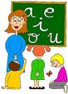

LISTAS DE COTEJO
ASPECTO:_______________________________________________________
BIMESTRE__________________________ASIGNATURA_________________________
F
E
C
H
A
N.L.
1
2
3
4
5
6
7
8
9
10
11
12
13
14
15
16
17
18
19
20
21
22
23
24
25
26
27
28
29
30
31
32
33
34
35



PRESTAMOS DE LOS LIBROS DE LA BIBLIOTECA

BIMESTRE__________________________ASIGNATURA_________________________
ALUMNO | LIBRO | FECHA DE PRESTAMO | FECHA DE ENTREGA | FIRMA DEL ALUMNO


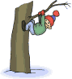
CUADRO DE CONDUCTA

BIMESTRE__________________________ASIGNATURA_________________________
ALUMNO | FECHA | INCIDENTE | OBSERVACIONES

NOTAS


____________________________________________________
____________________________________________________
____________________________________________________
____________________________________________________
____________________________________________________

______________________________________________________________________________________________________________________________________________________________________________________________________________________________________________________________________________________________________________________________________________________________________________________________________________________________________________________________________________________________________________________________________________________________________________________________________________________________________________________________________________________________________________________________________________________________________________________________________________________________________________________________________________________________________________________________________________________________________________________________________________________________________________________________________________________________________________________________________________________________________________________________________________________________________________________________________________________________________________________________________________________________________________________________________________________________________________________________________________________________________________________________________________________________________________________ _____
___________________________________________________ ______
__________________________________________________ ________
___________________________________________________________________

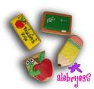

CONSEJO TECNICO


CUADRO DE COMISIONES DE CONSEJO TECNICO

C A R G O | R E S P O N S A B L E
PRESIDENTA
SECRETARIO
TECNICO PEDAGOGICO
P. N. L.
EVALUACIONES BIMESTRALES Y MATERIAL DE APOYO
TRAYECTO FORMATIVO
PROYECTO ESCOLAR
DEPORTES
ACCION SOCIAL
REFORESTACION
HIGIENE
ESCOLTA
COMPOSICION A LOS SIMBOLOS PATRIOS
TESORERO
PUNTUALIDAD Y ASISTENCIA
VIALIDAD
F E C H A S A C O N M E M O R A R
13 DE SEPTIEMBRE
15 DE SEPTIEMBRE
12 DE OCTUBRE
24 DE OCTUBRE
2 DE NOVIEMBRE
20 DE NOVIEMBRE
5 DE FEBRERO
24 DE FEBRERO
18 DE MARZO
21 DE MARZO
1° DE MAYO
5 DE MAYO

EFEMERIDES
MES | DIA | CONMEMORACION
 | 13 | Aniversario de los Niños Héroes
 | 15 | Conmemoración del grito de Independencia
SEPTIEMBE | 16 | Aniversario del Inicio de la Independencia de México 1810
 | 21 | Día internacional de La Paz
 | 27 | Aniversario de la Consumación de la Independencia 1821
OCTUBRE | 12 |   - Día de la Raza  - Aniversario del Descubrimiento de América  - Fundación e Chihuahua
 | 16 | Día Mundial de la Alimentación
 | 24 | Día de las Naciones Unidas
 | 02 | Día de Muertos
NOVIEMBRE | 20 |   Aniversario de la Revolución Mexicana 1910
 | 23 | Día de la armada de México
DICIEMBRE | 25 | Navidad
 | 31 | Fin de Año
ENERO | 06 | Día de los Reyes Magos
 | 05 | Aniversario de la Promulgación de las constituciones de 1857 y 1917
FEBRERO | 14 | Día del Amor y la Amistad
 | 19 | Día del Ejercito Mexicano
 | 24 | Día de la Bandera
MARZO | 18 |   Aniversario de la Expropiación Petrolera 1938
 | 21 | Aniversario del Natalicio de Don Benito Juárez 1806
ABRIL | 30 | Día del Niño
 | 01 | Día del Trabajo
MAYO | 05 | Aniversario de la Batalla de Puebla, Victoria sobre el ejército francés en 1862
 | 10 | Día de las Madres
 | 15 | Día del Maestro
JUNIO | 01 | Día de la Marina Nacional
 | 20 | Día del padre




DIRECTORIO DE MAESTROS

NOMBRE TEL. PARTICULAR TEL CELULAR

___________________________________________________________________
___________________________________________________________________
___________________________________________________________________
___________________________________________________________________
___________________________________________________________________
___________________________________________________________________
___________________________________________________________________
___________________________________________________________________
___________________________________________________________________
___________________________________________________________________
___________________________________________________________________
___________________________________________________________________
___________________________________________________________________
___________________________________________________________________
___________________________________________________________________
___________________________________________________________________
___________________________________________________________________________________________________________________________________________________________________________________________________________________________________________________________________________________________________________________________________________________________________________________________________________________________________________________________________________________________________________________________________________________________________________________________________________________________



CUMPLEAÑOS DEL PERSONAL
E N E R O
_____________________________________________________________________________________
M A R Z O
_____________________________________________________________________________________
F E B R E R O
_____________________________________________________________________________________




M A Y O
_____________________________________________________________________________________
A B R I L
_____________________________________________________________________________________
J U N I O
_____________________________________________________________________________________




J U L I O
_____________________________________________________________________________________
SEPTIEMBRE
_____________________________________________________________________________________
A G O S T O
_____________________________________________________________________________________



DICIEMBRE
_____________________________________________________________________________________
O C T U B R E
_____________________________________________________________________________________
NOVIEMBRE
_____________________________________________________________________________________





REUNIONES DE CONSEJO TECNICO
FECHA

ASUNTO (S):

ACUERDO (S):

NOTAS DE LA COMISION EN CONSEJO TECNICO


____________________________________________________
____________________________________________________
____________________________________________________
____________________________________________________
____________________________________________________
___________________________________________________________________________________________________________________________________________________________________________________________________________________________________________________________________________________________________________________________________________________________________________________________________________________________________________________________________________________________________________________________________________________________________________________________________________________________________________________________________________________________________________________________________________________________________________________________________________________________________________________________________________________________________________________________________________________________________________________________________________________________________________________________________________________________________________________________________________________________________________________________________________________________________________________________________________________________________________________________________________________________________________________________________________________________________________________________________________________________________________________________________________________________________________________________________________________________________________________________________________________________________________________________________________


PADRES
DE FAMILIA


BITACORA DE ASUNTOS A TRATAR CON PADRES DE FAMILIA
ALUMNO | FECHA | ASUNTO | OBSERVACIONES | FIRMA DEL PADRE O TUTOR


REUNIONES CON PADRES DE FAMILIA
FECHA

ASUNTO (S):

ACUERDO (S):

FIRMAS DE ASISTENCIA DE PADRES DE FAMILIA

NOMBRE DEL ALUMNO | FIRMA DEL PADRE O TUTOR
PRESIDENTE | SECRETARIO (A) | TESORERO (A)
ASUNTO:_______________________________________________________________________

NOTAS


____________________________________________________
____________________________________________________
____________________________________________________
____________________________________________________
___________________________________________________________________________________________________________________________________________________________________________________________________________________________________________________________________________________________________________________________________________________________________________________________________________________________________________________________________________________________________________________________________________________________________________________________________________________________________________________________________________________________________________________________________________________________________________________________________________________________________________________________________________________________________________________________________________________________________________________________________________________________________________________________________________________________________________________________________________________________________________________________________________________________________________________________________________________________________________________________________________________________________________________________________________________________________________________________________________________________________________________________________________________________________________________________________________________________________________________________________________________________________________________________________________



FIRMAS DE PERMISO DE VISITAS:

FECHA:_____________ LUGAR:___________________________

# | NOMBRE DEL ALUMNO | FIRMA DEL PADRE
1
2
3
4
5
6
7
8
9
10
11
12
13
14
15
16
17
18
19
20
21
22
23
24
25
26
27
28
29
30
31
32
33
34
35

PADRES QUE NOS ACOMPAÑAN
1.________________________________________________________________________
2.________________________________________________________________________
3.________________________________________________________________________
4.________________________________________________________________________
5.________________________________________________________________________

